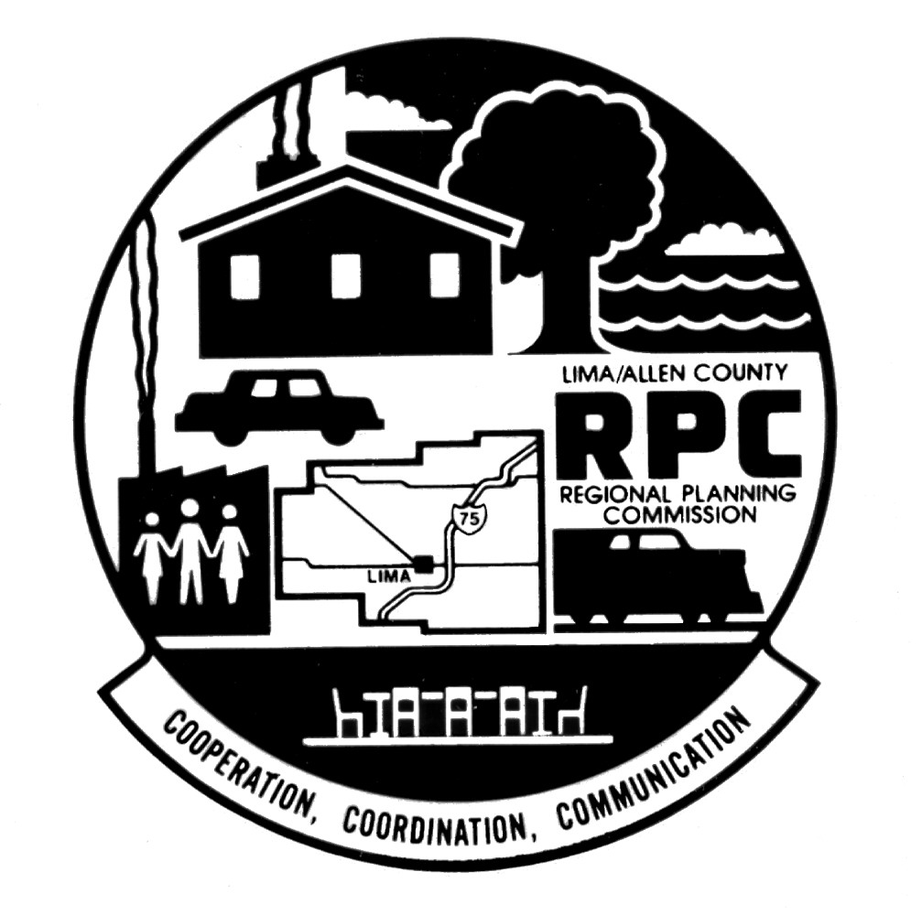
TO: DEVELOPMENTAL CONTROLS COMMITTEE
COOPERATION, COORDINATION, COMMUNICATION
Steve Ewing
President

Howard Elstro
President-Elect

Dave Belton
Treasurer

Robert Sielschott
Secretary

Shane A. Coleman
Executive Director
RECYCLED PAPER
LIMA-ALLEN COUNTY REGIONAL PLANNING COMMISSION
130 West North Street Lima, Ohio 45801-4311
Telephone: 419-228-1836 FAX: 419-228-3891
www.lacrpc.com

Mr. Paul Basinger Mr. Brad Baxter
Mr. Mark Bishop Mr. Kevin Cox
Mr. Steve Ewing Mr. Jerry Gilden
Mr. Kent McCleary Mr. Doug Post
Mr. Walter Rysz

FROM: Chuck Schierloh, Chairman

DATE: August 11, 2021

RE: D C C Meeting

The meeting of the Developmental Controls Committee of the Lima-Allen County Regional Planning Commission scheduled for Tuesday, August 17, 2021, has been cancelled. An agenda will be mailed when the next meeting of the DCC is scheduled.

